Design And Apply Context-Aware Access Controls Based On User Identity, Device Posture, Location, And Application Risk.

Group Details:

S.NO | NAME | COLLEGE | CONTACT
1 | Dharnish M | Texcity Arts & Science College | dharnish2405@gmail.com
2 | Fathima A | Texcity Arts & Science College | fathimanafih15@gmail.com
3 | Selva Ganesh S | Texcity Arts & Science College | selvaganeshs4033@gmail.com
4 | Arul Prakash G | Texcity Arts & Science College | garul9715@gmail.com

INTRODUCTION
In an era where the digital landscape is constantly evolving, organizations face an ever-increasing threat from cyberattacks. The need for swift and effective incident response has become paramount to safeguard sensitive data, protect digital assets, and maintain the trust of stakeholders. In response to this growing challenge, we present a visionary project: the development of an AI-driven incident response platform that empowers cybersecurity teams with the tools to automate and enhance incident triage and response tasks.

The traditional network perimeter has all but dissolved in the modern digital landscape. With the mass adoption of cloud services, remote work, and personal mobile devices (BYOD), corporate resources are no longer confined to a single office building. This shift has rendered the conventional "castle-and-moat" security model—where anyone inside the network is trusted by default—obsolete and dangerously insufficient. Modern organizations now face the complex challenge of securing access to sensitive data from a diverse and ever-changing array of locations, devices, and user environments. To address this, security strategies must evolve from static, location-centric models to dynamic, identity-centric frameworks that assess the risk of every access request in real-time.

This project focuses on the design and implementation of a context-aware access control system to solve
this exact challenge. By moving beyond simple username and password verification, this system will evaluate a rich set of contextual signals before granting access to applications and data. These signals include the user's identity and role, the security posture of their device (e.g., is it patched, encrypted, and managed?), their geographic location, and the inherent risk level of the application they are attempting to use. By analyzing these factors in unison, the system can make a granular, real-time decision: grant full access, restrict access to certain features, require step-up authentication (like multi-factor authentication), or block the request entirely.

Ultimately, this project aims to build a security architecture that is both robust and frictionless. For example, a trusted employee accessing a low-risk application from a secured corporate laptop on the office network might have a seamless login experience. Conversely, that same employee attempting to access a critical financial system from an unpatched personal device in a foreign country would be met with additional security challenges or be completely blocked. This intelligent, adaptive approach not only significantly reduces the attack surface and protects against compromised credentials but also enables a secure and productive work environment for a modern, mobile workforce.
ABSTRACT
The increasing adoption of cloud services, mobile computing, and hybrid work models has fundamentally broken the traditional network perimeter, rendering legacy access control models ineffective. Organizations now struggle to protect sensitive data from a growing attack surface, where threats can originate from compromised endpoints, unsafe locations, or malicious insiders. Static, binary decisions (allow or deny) are no longer sufficient to mitigate the sophisticated risks present in modern distributed environments. There is a critical need for a dynamic security framework that can evaluate the full context of every access request in real-time.

This project presents the design and application of a context-aware access control system based on user identity, device posture, geolocation, and application risk. The objective is to develop a policy engine that ingests multiple contextual signals to calculate a real-time risk score for each access attempt. The methodology involves defining granular policies that map specific context combinations (e.g., "managed device" + "corporate network" + "low-risk app") to corresponding access decisions, such as granting full access, enforcing step-up authentication (MFA), limiting session functionality, or denying access entirely.

The expected outcome is an adaptive security model that significantly reduces the organizational attack
surface and mitigates the risk of credential compromise.

By ensuring that access decisions are dynamically aligned with the perceived threat level of each request, the system enhances security without introducing unnecessary friction for low-risk, trusted users. This approach provides a robust framework for enabling secure and productive access to resources in an increasingly perimeter-less and dynamic digital world.
USE CASE SCENARIOS

Scenario 1: Finance Department Access to ERP System
A senior accountant in the finance department needs to access the corporate Enterprise Resource Planning (ERP) system to process monthly payroll. The user connects from a remote location using their company-managed laptop. Upon launching the ZPA Client Connector, they authenticate via Azure Active Directory with multi-factor authentication (MFA). ZPA evaluates the user's identity, group membership (Finance_ERP_Users), device posture (antivirus active, disk encryption enabled), and connection context. The policy engine determines that the user is authorized and brokers a secure, direct micro-tunnel to the ERP application only. The user can interact with the ERP interface, but has no visibility or network-level access to any other internal systems, such as development servers or the HR database.

Output:
- User authenticated and authorized based on identity and group membership.
- Direct micro-tunnel established specifically to the ERP application.
- All other internal applications and network segments remain invisible and inaccessible.

Scenario 2: Contractor Access to Specific Project Repository
An external software consultant is hired for a three-month project and requires access only to a specific Git repository hosted on an internal server. The contractor is onboarded as a guest user in the identity provider and assigned to the "Project_X_Contractors" group. When the contractor connects using the ZPA client, the system verifies their identity and checks the device for basic security compliance (OS patch level, firewall enabled). ZPA enforces a policy that grants access exclusively to the Git repository application (port 22/SSH or port 443/HTTPS) during business hours (9 AM to 5 PM). The contractor can clone, push, and pull code, but cannot discover or connect to any other internal resources, including the corporate intranet or file servers.
Output:
- Time-bound and role-specific access enforced.
- Contractor restricted to a single application (Git repository).
- Lateral movement to adjacent systems completely blocked.

Scenario 3: Executive Access to Confidential Board Documents
A company executive needs to access a confidential folder containing board meeting materials hosted on an internal file server. The executive connects from a tablet device while traveling internationally. ZPA integrates with the mobile device management (MDM) solution to verify that the tablet is compliant (not jailbroken, passcode enabled, encryption active). Upon successful authentication, ZPA evaluates the policy: "If user is in 'Executive_Board' group AND device is MDM-compliant AND connection is from a trusted country (allowlist), THEN grant access to 'Board_Documents' application." The executive is connected directly to the specific file share, and all data in transit is encrypted via TLS. Any attempt to access other shares or network resources is automatically blocked and logged.

Output:
- Context-aware access based on user role, device posture, and geographic location.
- Granular access to a specific file share (Board_Documents) .
- Comprehensive logging of access events for audit and compliance.

Scenario 4: IT Administrator Access to Server Management Interfaces
A systems administrator requires access to management interfaces (SSH for Linux servers and RDP for Windows servers) to perform routine maintenance. Instead of granting VPN access to the entire management network, ZPA is configured to treat each server or management interface as a separate application segment. The administrator authenticates and is presented only with the specific servers they are authorized to manage based on their IT subgroup (e.g., "Linux_Admins" see only Linux servers; "Windows_Admins" see only Windows servers). When the admin connects via SSH to a Linux server, ZPA creates a direct micro-tunnel to that specific IP and port combination. The admin cannot scan the subnet, access other servers, or initiate connections to non-authorized ports.
Output:
- Micro-segmentation at the individual server/interface level .
- Role-based access controlling visibility of specific management consoles .
- Elimination of network-level reconnaissance capabilities for admins.

Scenario 5: Mergers and Acquisitions Integration
A company acquires a smaller firm and needs to provide the acquired company's HR team with temporary access to the parent company's benefits enrollment application. The acquired company's users are added as external collaborators in the identity provider with limited attributes. ZPA policies are created that specifically grant the "Acquired_HR" group access only to the "Benefits_App" (a web application hosted internally). The acquired users install the ZPA client, authenticate, and are connected directly to the benefits application. Because ZPA provides access without network connectivity, the parent company's entire internal network remains completely hidden and protected. The acquired users cannot ping, scan, or access any other corporate resource. After six months, when the integration is complete and users are migrated to the parent identity system, the temporary policies are revoked.

Output:
- Secure, temporary access provided without network exposure.
- Complete network invisibility protecting the parent company's infrastructure.
- Simplified deprovisioning through policy revocation rather than complex network changes.
Stage - 1

Title : OWASP Top 10

OVERVIEW
The OWASP Top 10 is a globally recognized awareness document that identifies the most critical security risks affecting web applications. It is designed to help developers, security professionals, and organizations understand common vulnerabilities and implement better security practices throughout the software development lifecycle. By highlighting the most frequently exploited weaknesses, the OWASP Top 10 serves as a practical guide for improving application security and reducing the risk of cyberattacks.
The OWASP Top 10 covers major security issues that commonly lead to system compromise and data breaches. These risks include Broken Access Control, where users can access resources or perform actions beyond their permissions, and Cryptographic Failures, where sensitive data is not properly protected through encryption. Injection attacks, such as SQL injection, occur when untrusted input is interpreted as commands or queries by an application. Additionally, Insecure Design arises from poor architectural decisions that fail to consider security during the design phase of a system.
Other important risks include Security Misconfiguration, which occurs when systems are deployed with incorrect or default settings that expose vulnerabilities. Vulnerable and Outdated Components refer to the use of third-party libraries or frameworks with known security flaws. Identification and Authentication Failures may allow attackers to bypass login mechanisms or impersonate legitimate users. Software and Data Integrity Failures occur when applications do not verify the integrity of software updates or external code.
The list also includes Security Logging and Monitoring Failures, where insufficient logging prevents organizations from detecting or responding to attacks in time. Another significant risk is Server-Side Request Forgery (SSRF), where attackers manipulate a server into making unauthorized requests to internal or external systems. By understanding and addressing these vulnerabilities, organizations can strengthen their security posture, protect sensitive data, and maintain the reliability and trustworthiness of their applications.
List of Vulnerability:

S.NO | Vulnerability Name | CWE / CVE No.
1 | Absolute Path Traversal | CWE - 36
2 | Sensitive Cookie in HTTPS Session Without 'Secure' Attribute | CWE - 614
3 | Use of Unmaintained Third Party Components | CWE - 1104
4 | Weak Encoding for Password | CWE - 261
5 | Improper Input Validation | CWE - 20
6 | Missing Encryption of Sensitive Data | CWE - 311
7 | Improper Authentication | CWE - 287
8 | Embedded Malicious Code | CWE - 506
9 | Information Loss or Omission | CWE - 221
10 | Divide By Zero | CWE - 369

Report:
1. Vulnerability Name : Absolute Path Traversal

CWE/CVE No : CWE - 36

Owasp Category : A01:2025 Broken Access Control

Description : The product uses external input to construct a pathname that should be within a restricted directory, but it does not properly neutralize absolute path sequences such as "/abs/path" that can resolve to a location that is outside of that directory.

Business Impact : Absolute path traversal vulnerabilities can enable attackers to access restricted files on the server, potentially exposing confidential data, application secrets, or system configuration information that could compromise the entire system.

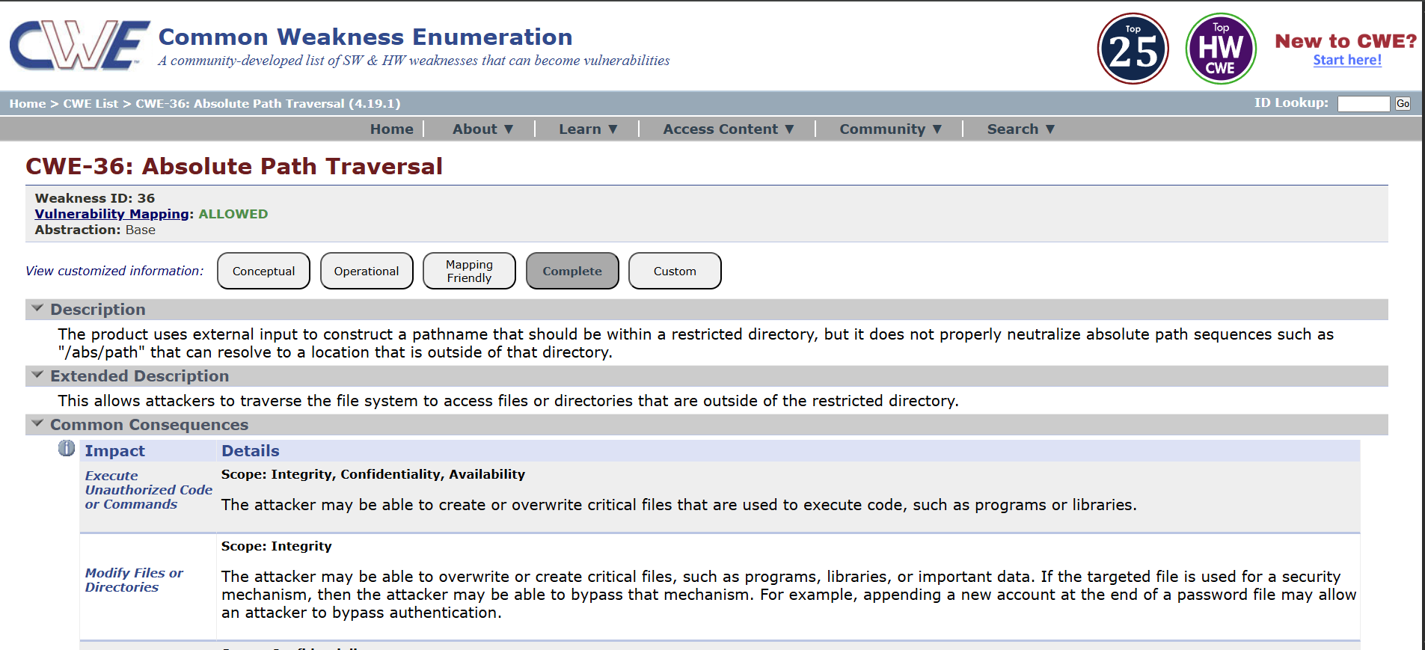

2. Vulnerability Name : Sensitive Cookie in HTTPS Session Without 'Secure' Attribute

CWE/CVE No : CWE - 614

Owasp Category : A02:2025 - Security Misconfiguration

Description : This vulnerability occurs when a web application sets sensitive cookies such as session IDs or authentication tokens over HTTPS but fails to include the Secure attribute. Without this attribute, the browser may transmit the cookie over an unencrypted HTTP connection, making it possible for attackers on the network to intercept the cookie. If an attacker captures the session cookie, they may hijack the user's session and gain unauthorized access to the application.

Business Impact : Missing the Secure attribute on sensitive cookies can allow attackers to intercept session data, leading to session hijacking, unauthorized account access, exposure of sensitive information, and potential financial, legal, and reputational damage to the organization.

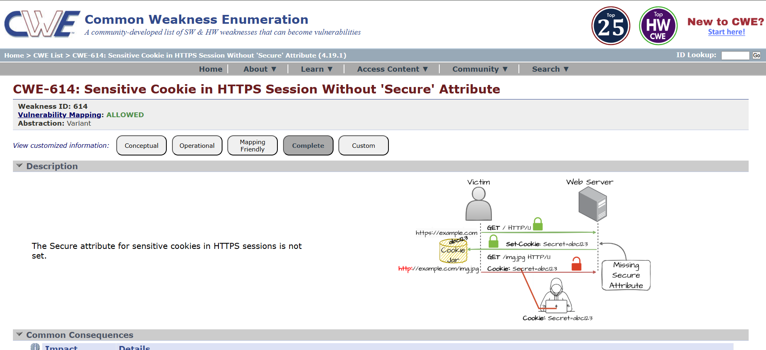

3. Vulnerability Name : Use of Unmaintained Third Party Components

CWE/CVE No : CWE - 1104

Owasp Category : A03:2025 - Software Supply Chain Failures

Description : This vulnerability occurs when an application depends on third-party libraries, frameworks, or components that are no longer actively maintained or supported by their developers. Because these components do not receive security updates, bug fixes, or patches, any newly discovered vulnerabilities remain unaddressed. Attackers may exploit these known weaknesses to compromise the application or underlying system.
Business Impact : Using unmaintained third-party components increases the risk of exploitation through known vulnerabilities, which can lead to system compromise, data breaches, service disruption, regulatory compliance issues, and reputational damage for the organization.

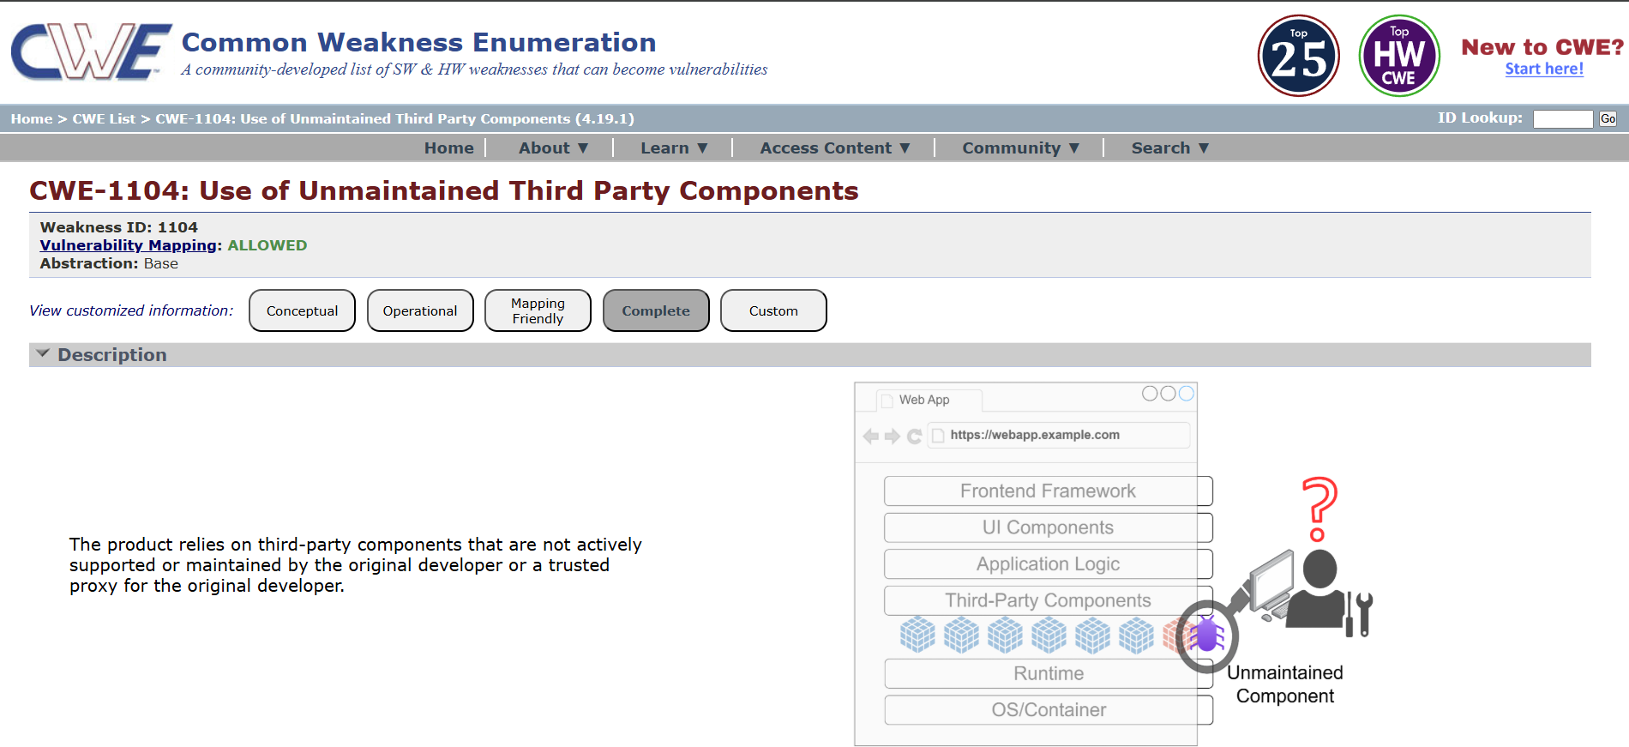

4. Vulnerability Name : Weak Encoding for Password

CWE/CVE No : CWE - 261

Owasp Category : A04:2025 Cryptographic Failures

Description : This vulnerability occurs when an application stores or processes passwords using weak encoding mechanisms such as Base64 or other reversible encoding techniques instead of strong cryptographic hashing. Because encoding methods are easily reversible, attackers who gain access to encoded passwords can quickly decode them and retrieve the original plaintext passwords, compromising user accounts.

Business Impact : Weak encoding of passwords can allow attackers to easily recover user credentials if the data is exposed, leading to account compromise, unauthorized access to systems, potential data breaches, regulatory penalties, and damage to the organization's reputation.
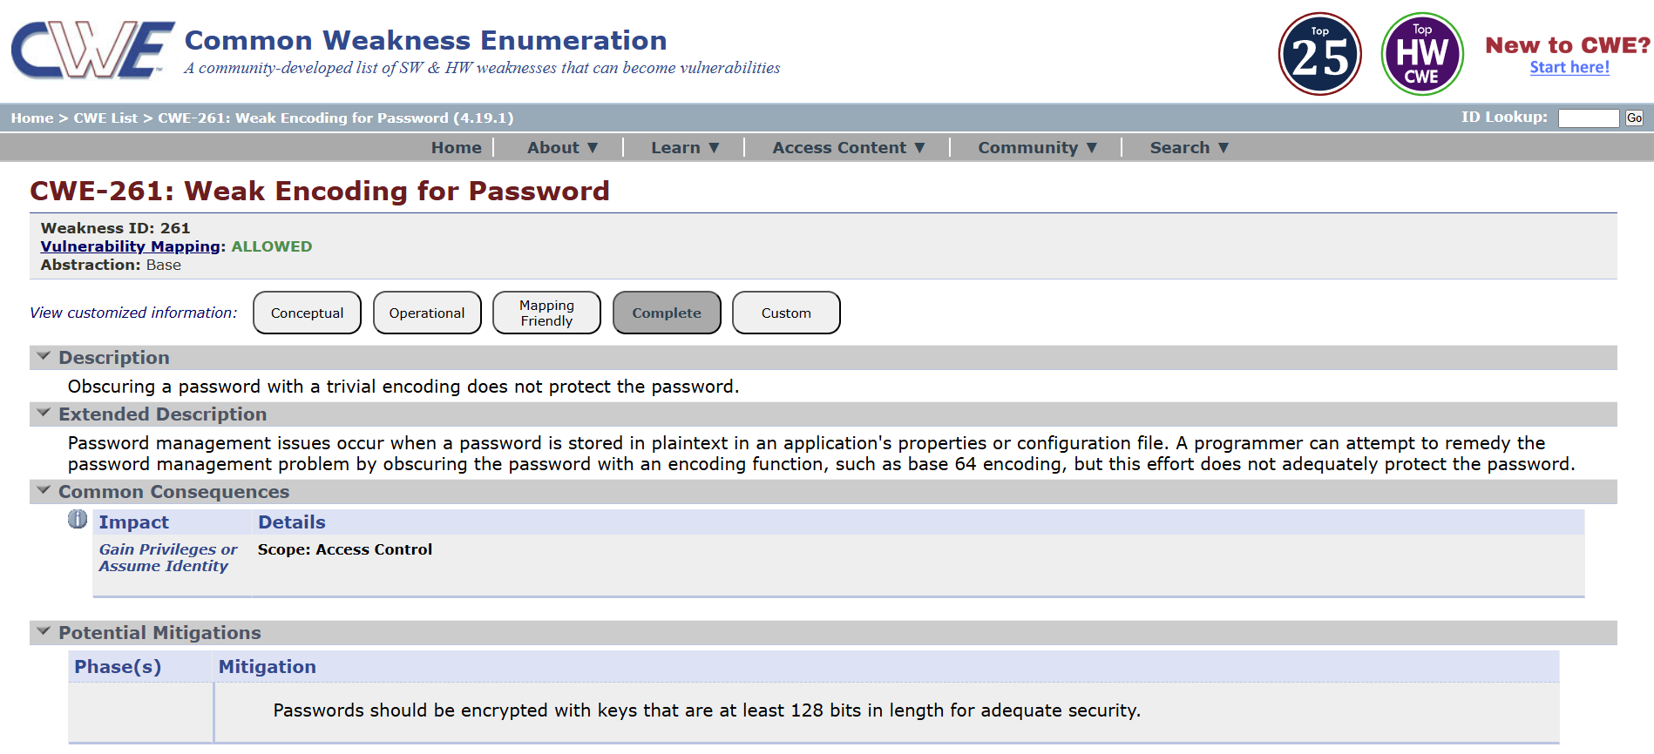

5. Vulnerability Name : Improper Input Validation

CWE/CVE No : CWE - 20

Owasp Category : A05:2025 Injection

Description : This vulnerability occurs when an application fails to properly validate or sanitize user input before processing it. If input data from users, forms, APIs, or external systems is not strictly checked for type, length, format, or allowed values, attackers may submit malicious input that manipulates application behavior or exploits underlying systems.

Business Impact : Improper input validation can allow attackers to inject malicious data, potentially leading to system compromise, data manipulation, unauthorized access, application crashes, and significant financial, operational, and reputational damage to the organization.
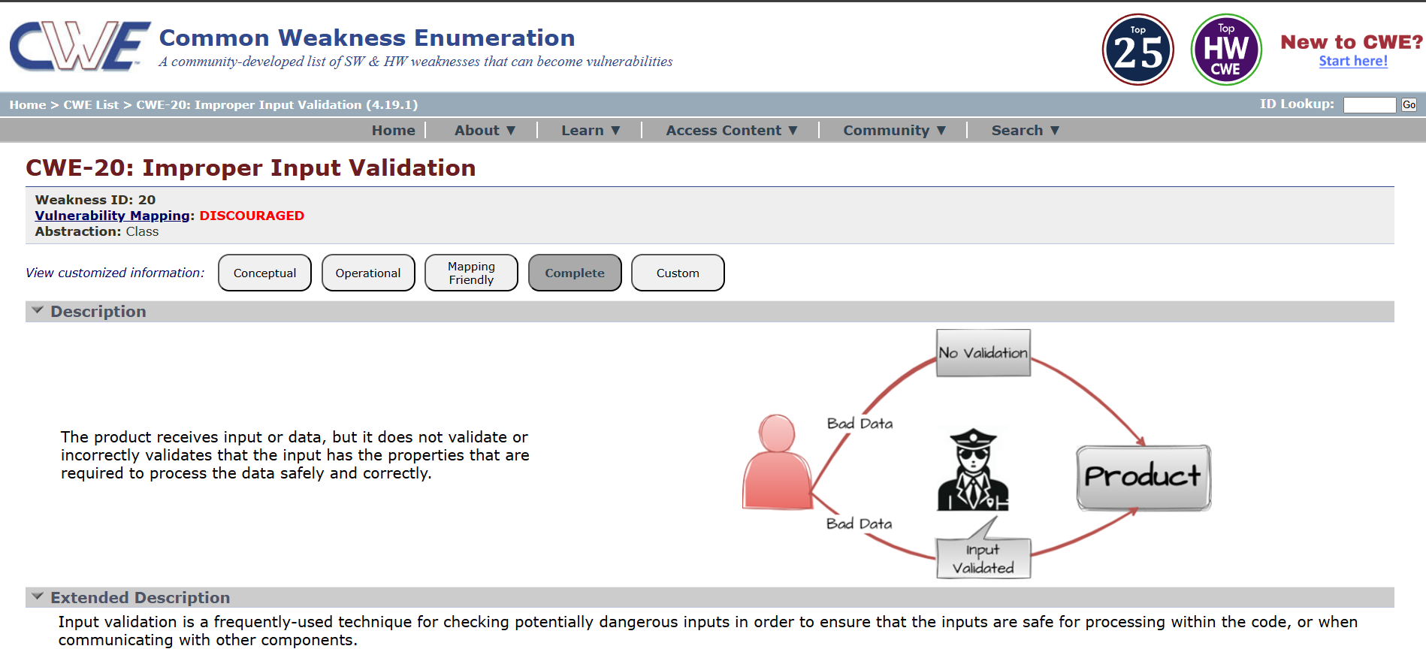

6. Vulnerability Name : Missing Encryption of Sensitive Data

CWE/CVE No : CWE - 311

Owasp Category : A06:2025 Insecure Design

Description : This vulnerability occurs when sensitive information such as passwords, personal data, financial details, or confidential business data is transmitted or stored without proper encryption. Without encryption, the data can be easily intercepted, read, or modified by unauthorized parties during transmission or storage.

Business Impact : Missing encryption for sensitive data can lead to unauthorized disclosure of confidential information, resulting in data breaches, financial loss, regulatory penalties, legal liabilities, and significant damage to the organization's reputation.
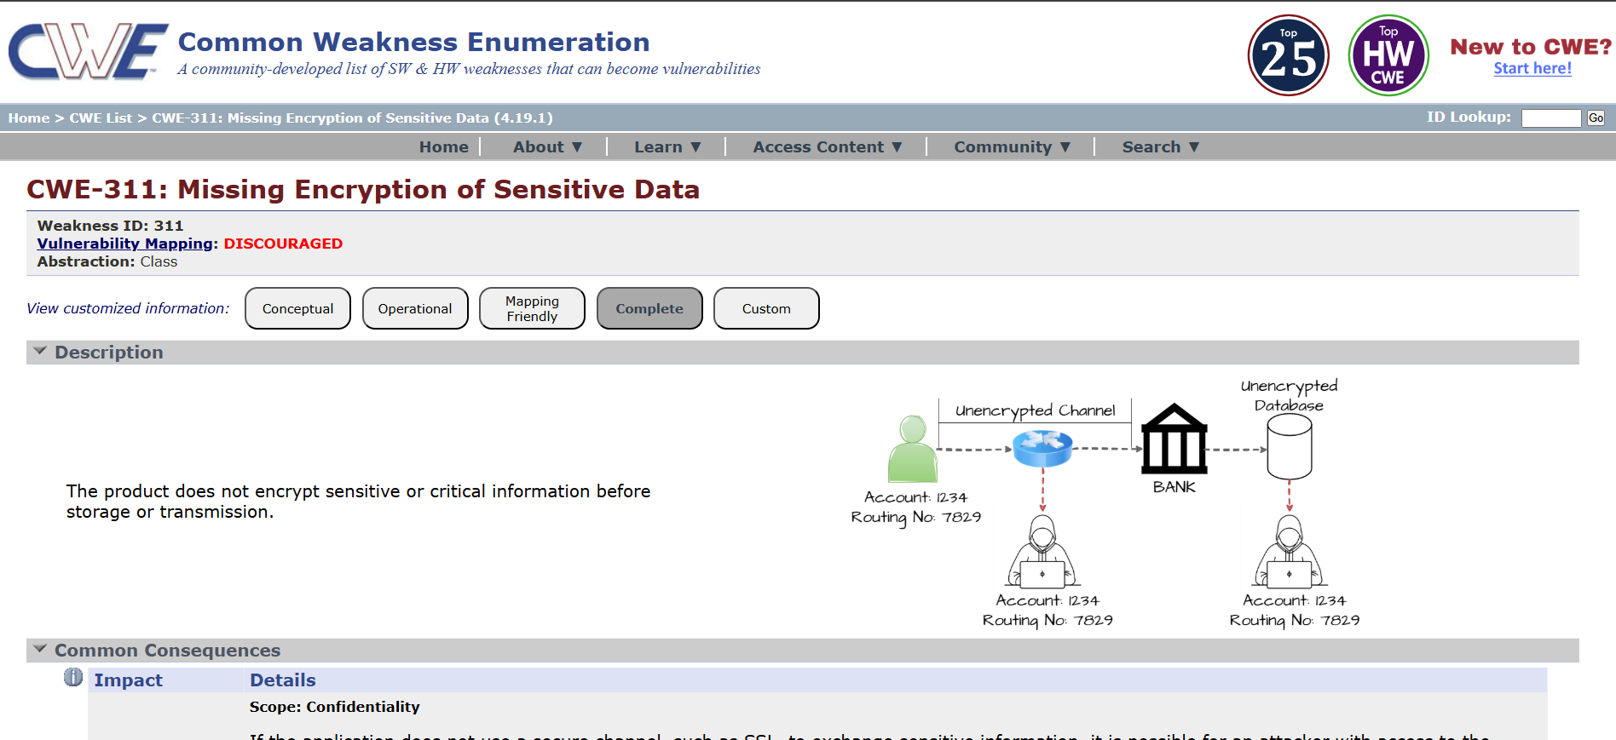

7. Vulnerability Name : Improper Authentication

CWE/CVE No : CWE - 287

Owasp Category : A07:2025 Authentication Failures

Description : This vulnerability occurs when an application fails to properly verify the identity of users before granting access to protected resources or functionalities. Weak or flawed authentication mechanisms such as missing authentication checks, predictable credentials, or flawed login logic may allow attackers to bypass authentication controls.

Business Impact : Improper authentication can allow attackers to gain unauthorized access to user accounts or critical systems, potentially leading to data breaches, service disruption, financial losses, and reputational damage for the organization.

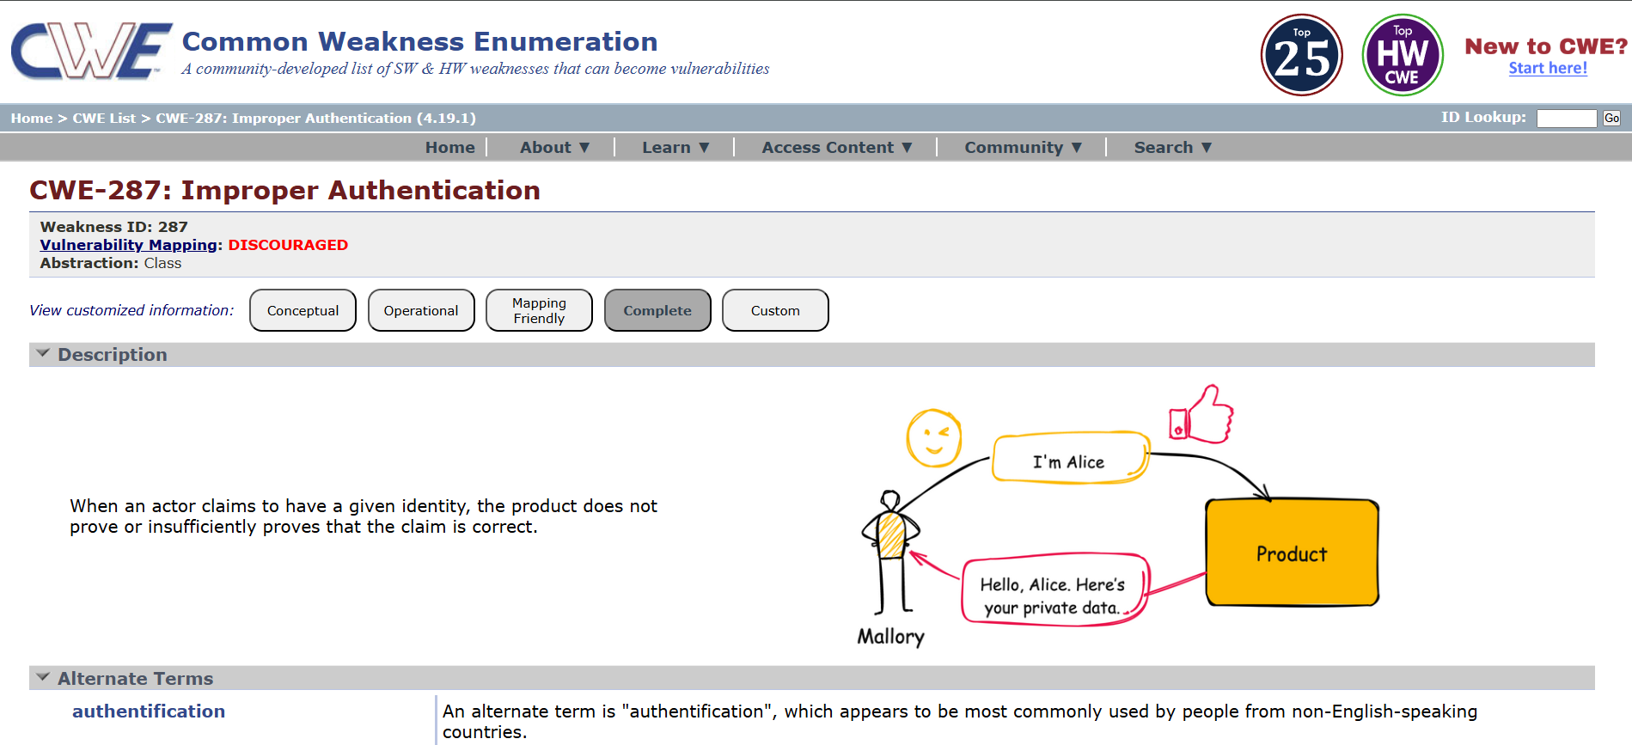

8. Vulnerability Name : Embedded Malicious Code

CWE/CVE No : CWE - 506

Owasp Category : A08:2025 Software or Data Integrity Failures

Description : This vulnerability occurs when malicious code is intentionally embedded within an application or software component. The hidden code may perform unauthorized actions such as creating backdoors, leaking sensitive data, bypassing security controls, or executing harmful operations without the knowledge of users or administrators.

Business Impact : Embedded malicious code can compromise system integrity and confidentiality, potentially allowing attackers to steal sensitive data, gain persistent unauthorized access, disrupt services, and cause significant financial, operational, and reputational damage to the organization.
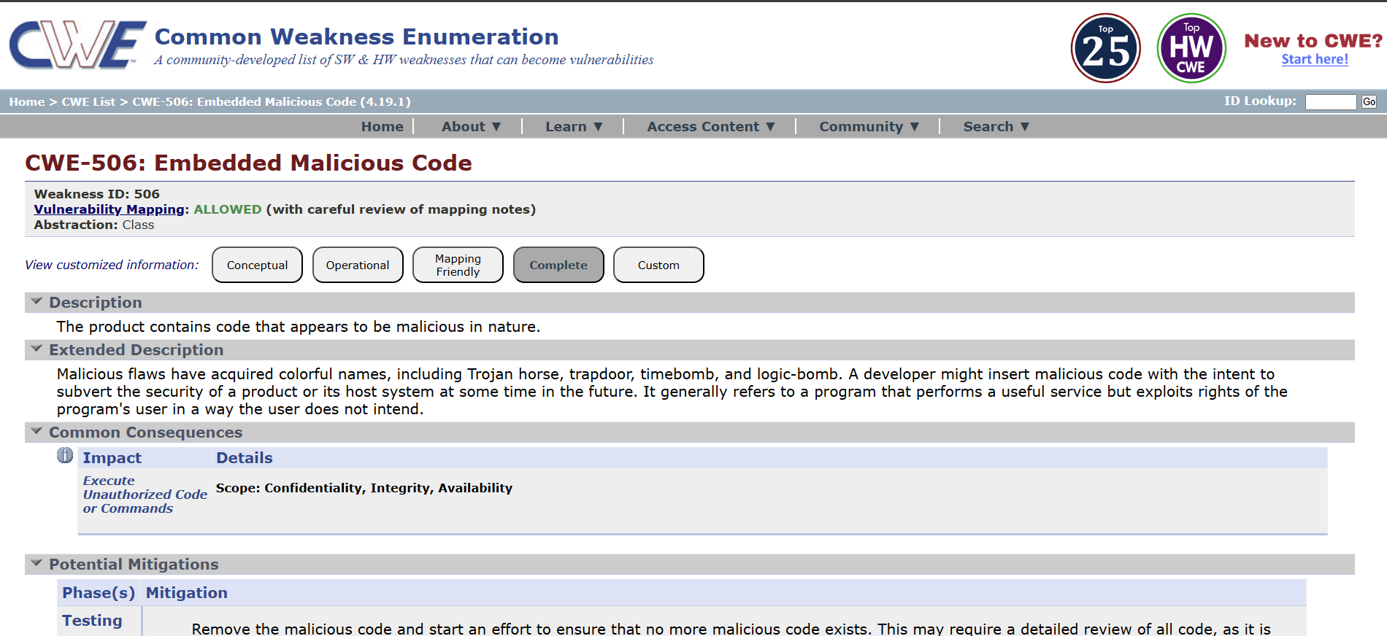

9. Vulnerability Name : Information Loss or Omission

CWE/CVE No : CWE - 221

Owasp Category : A09:2025 Security Logging & Alerting Failures

Description : This vulnerability occurs when important information is accidentally lost, omitted, or not properly preserved during data processing, logging, transmission, or storage. Such omissions may happen due to improper system design, incomplete data handling, or incorrect implementation of data validation and logging mechanisms, which can result in incomplete or inaccurate information being recorded or processed.

Business Impact : Information loss or omission can lead to inaccurate records, compliance issues, operational errors, and difficulty in auditing or incident investigation, potentially resulting in financial loss, legal risks, and reduced trust in the organization’s systems and services.
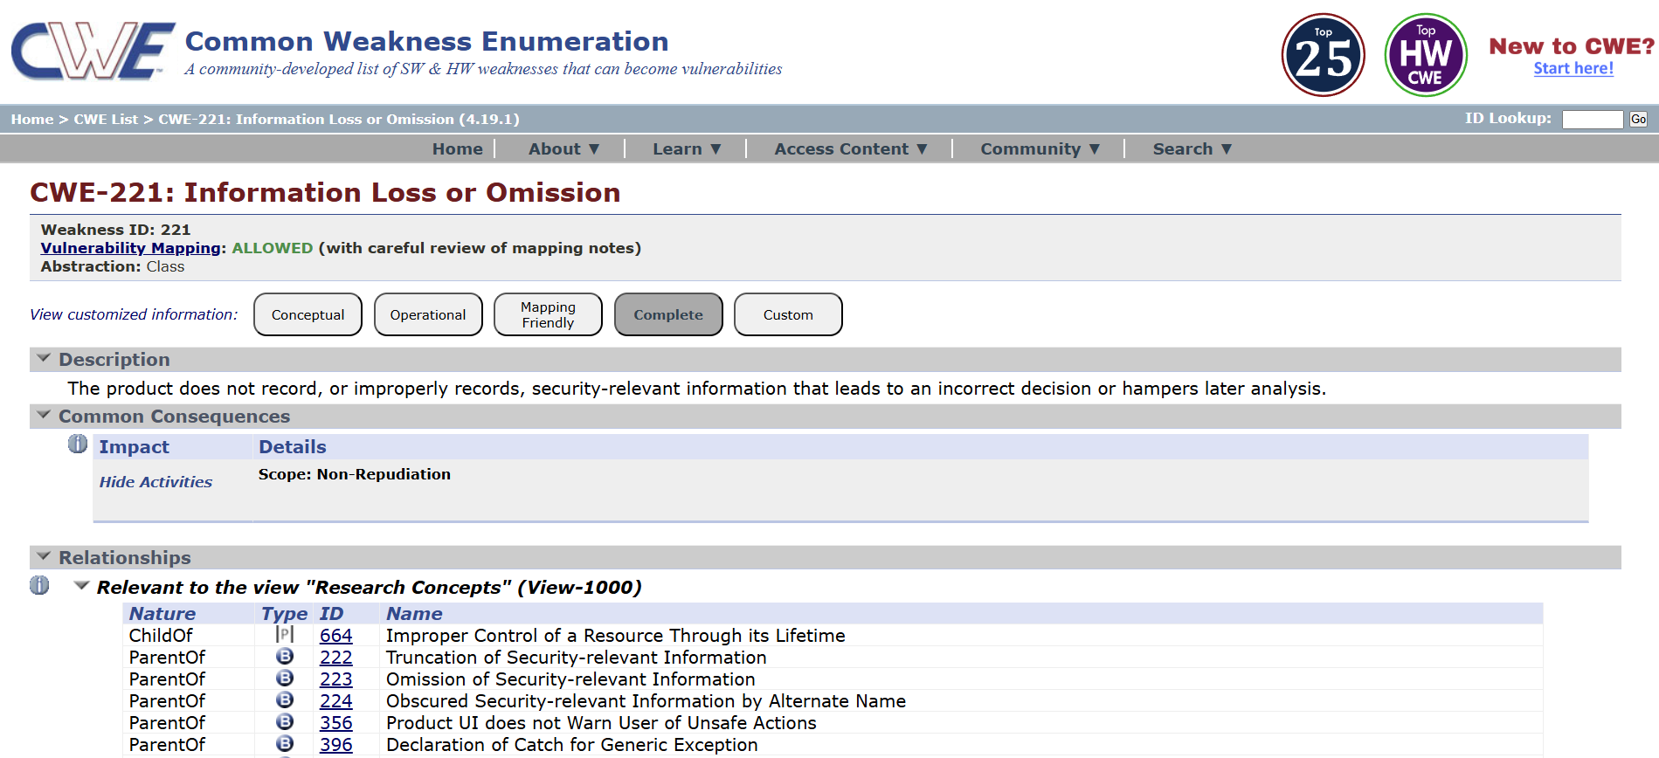

10. Vulnerability Name : Divide By Zero

CWE/CVE No : CWE - 369

Owasp Category : A10:2025 Mishandling of Exceptional Conditions

Description : This vulnerability occurs when a program performs a division operation without checking whether the divisor is zero. If the divisor becomes zero during execution, the application may generate runtime errors, crash, or behave unexpectedly, which can disrupt normal application functionality.

Business Impact : Divide-by-zero vulnerabilities can cause application crashes or service disruptions, potentially leading to denial of service, reduced system reliability, operational downtime, and negative impact on business continuity and user trust.

Stage - 2

Title : NESSUS Scan

OVERVIEW
A Nessus scan is a widely used vulnerability assessment method for identifying security weaknesses in computer systems, networks, and applications. Nessus is developed by Tenable and is designed to help organizations detect vulnerabilities, misconfigurations, outdated software, and potential security risks before attackers can exploit them. It works by scanning systems, servers, databases, and network devices to compare them against a large database of known vulnerabilities and security issues.
During a Nessus scan, the tool analyzes the target system by checking open ports, installed software versions, system configurations, and security settings. It then identifies known vulnerabilities such as missing patches, weak encryption protocols, insecure services, and misconfigured access controls. Nessus uses regularly updated vulnerability plugins to ensure that newly discovered threats are also detected during the scanning process.
After the scan is completed, Nessus generates a detailed report that categorizes vulnerabilities based on severity levels such as Critical, High, Medium, Low, and Informational. The report also provides descriptions of each vulnerability, potential risks, and recommended remediation steps to help organizations fix the identified issues. Security teams often use these reports to prioritize vulnerabilities and improve their overall security posture.
Nessus scanning is commonly used in vulnerability assessments, penetration testing, compliance auditing, and continuous security monitoring. By regularly performing Nessus scans, organizations can proactively identify security weaknesses, reduce the risk of cyberattacks, and maintain a secure IT infrastructure.

S.NO | Vulnerability | Severity | Plugin
1 | Service Detection | Info | 22964
2 | Nessus SYN Scanner | Info | 11219
3 | Additional DNS Hostnames | Info | 46180
4 | OS Fingerprints Detected | Info | 209654
5 | Traceroute Information | Info | 10287

REPORT

1. Vulnerability Name: Service Detection

Severity : Info

Plugin : 22964

Description : Service Detection refers to the identification of running services and their corresponding ports on a system during a network scan. Tools such as Nessus detect open ports and determine the service type, version, and protocol running on those ports. While service detection itself is not always a vulnerability, it reveals information about the system’s exposed services. Attackers can use this information to map the target environment and identify potential entry points or known vulnerabilities associated with those services.

Solution : To mitigate the risk of service detection, organizations should minimize the exposure of unnecessary services and close unused ports. Network security controls such as firewalls and access control lists should be implemented to restrict access to essential services only. Additionally, services should be kept updated with the latest security patches, and banner information that reveals service versions should be disabled where possible.
Business Impact : If service information is exposed, attackers may gain insight into the technologies and services running within the organization’s infrastructure. This information can be used for reconnaissance, enabling attackers to identify outdated or vulnerable services and launch targeted attacks. As a result, it may increase the risk of unauthorized access, exploitation of vulnerabilities, and potential disruption of business operations.

2. Vulnerability Name : Nessus SYN Scanner

Severity : Info

Plugin : 11219

Description : The Nessus SYN Scanner performs a TCP SYN scan to identify open ports and active services on a target system. This technique sends a SYN packet to the target port and analyzes the response to determine whether the port is open, closed, or filtered. While this scanning method is commonly used for security assessments, it can reveal exposed services and network configurations. If such services are publicly accessible, attackers may use this information during reconnaissance to identify potential attack vectors.

Solution : Restrict unnecessary open ports and disable unused services on the system. Implement firewall rules and network segmentation to limit access only to trusted sources. Intrusion Detection/Prevention Systems (IDS/IPS) should be used to monitor and block suspicious scanning activities. Regular security assessments and timely patching of exposed services will further reduce the risk of exploitation.

Business Impact : Exposure of open ports and detectable services can provide attackers with valuable information about the organization’s infrastructure. This reconnaissance data may help adversaries identify vulnerable services, outdated software, or misconfigured systems. Successful exploitation could lead to unauthorized access, data breaches, service disruption, or compromise of critical business systems.
3. Vulnerability Name : Additional DNS Hostnames

Severity : Info

Plugin : 46180

Description : The Additional DNS Hostnames finding indicates that multiple hostnames are associated with the same IP address in the Domain Name System (DNS). During scanning, Nessus identifies other DNS records that resolve to the target system. These hostnames may represent additional domains, subdomains, or services hosted on the same server. While this is typically an informational finding, it may reveal internal or unused hostnames that could provide attackers with additional targets for reconnaissance or further attacks.

Solution : Review all DNS records associated with the identified IP address and remove any unnecessary or outdated hostnames. Ensure that only required domains and subdomains are publicly accessible. Implement proper DNS management practices and regularly audit DNS configurations to prevent unintended exposure of internal or unused hostnames.

Business Impact : Exposure of additional DNS hostnames can provide attackers with more information about the organization’s infrastructure and hosted services. This information may assist in reconnaissance activities, enabling attackers to identify hidden services, development environments, or misconfigured systems that could be exploited. In some cases, it may increase the attack surface of the organization.

4. Vulnerability Name : OS Fingerprints Detected

Severity : Info

Plugin : 209654

Description : The OS Fingerprints Detected finding indicates that the operating system of the target host can be identified through network scanning techniques. Using tools such as Nessus, the scanner analyzes network responses, TCP/IP stack behavior, and system characteristics to determine the probable operating system running on the target machine. This information disclosure may allow attackers to identify the underlying platform and tailor their attacks based on known vulnerabilities associated with that operating system.

Solution : Limit unnecessary exposure of system information by configuring firewalls, intrusion prevention systems, and network devices to restrict OS fingerprinting attempts. Disable unnecessary services and apply the latest security patches and updates to the operating system. Additionally, network security controls should be implemented to detect and block suspicious scanning activities.

Business Impact : If the operating system details are exposed, attackers can use this information during the reconnaissance phase to identify potential vulnerabilities specific to that OS. This may increase the likelihood of targeted attacks, exploitation of unpatched vulnerabilities, and unauthorized access to systems, which could lead to data compromise or disruption of business operations.

5. Vulnerability Name : Traceroute Information

Severity : Info

Plugin : 10287

Description : Traceroute Information indicates that the network path to the target system can be identified through traceroute techniques. Security scanning tools such as Nessus use traceroute to discover intermediate network devices, routers, and hops between the scanner and the target host. This information reveals details about the network infrastructure and routing path used to reach the system.

Solution : Restrict or filter traceroute-related traffic where possible using firewalls and network security controls. Configure network devices to limit the exposure of internal routing information. Implement proper network segmentation and ensure that unnecessary network responses that reveal infrastructure details are minimized.

Business Impact : Exposure of traceroute information may allow attackers to understand the network topology and identify intermediate network devices. This knowledge can assist attackers during reconnaissance by revealing potential network entry points, security devices, or infrastructure components that could be targeted in further attacks.

Stage - 3

Title : Design And Apply Context-Aware Access Controls Based On User Identity, Device Posture, Location, And Application Risk.

OVERVIEW
In modern enterprise environments, users access corporate resources from multiple devices, networks, and locations. This dynamic work environment increases security risks because traditional security models often rely only on network-based access control, which cannot adequately verify the trustworthiness of users or devices. To address these challenges, organizations are adopting context-aware access control systems that evaluate multiple security factors before granting access to applications and data.
This project focuses on designing and implementing context-aware access controls that make access decisions based on various contextual attributes such as user identity, device posture, geographic location, and application risk level. Instead of granting broad network access, the system evaluates each access request dynamically to ensure that only legitimate users with secure devices and appropriate permissions can access sensitive applications. By incorporating identity verification, device compliance checks, and location-based policies, the system strengthens overall access security.
The proposed solution follows the principles of modern Zero Trust security architecture, where every access request is continuously verified regardless of where the user is located. Access policies are designed to enforce strict authentication and authorization requirements while maintaining a seamless user experience. Through this approach, organizations can reduce unauthorized access, prevent compromised devices from connecting to critical systems, and limit exposure to potential cyber threats.
Ultimately, implementing context-aware access controls helps organizations build a more resilient and adaptive security framework. By combining identity-based authentication, device health verification, location awareness, and risk-based application access, the project enhances security posture while supporting secure and flexible access to enterprise resources.

Context-Aware Access Control Architecture :
The architecture of context-aware access control is designed to evaluate multiple contextual factors before granting access to enterprise applications and resources. Instead of relying solely on network location, this architecture analyzes attributes such as user identity, device security posture, geographic location, and application sensitivity. When a user attempts to access an application, the system verifies these contextual parameters through centralized security services and identity management systems. Based on the evaluation results, the system dynamically determines whether the request should be allowed, restricted, or denied. This architecture enhances security by ensuring that access decisions are based on real-time context rather than static network permissions.

Identity-Based Authentication and Authorization :
Identity-based authentication and authorization ensure that only verified users are granted access to organizational resources. In this model, access control decisions are primarily based on the identity of the user rather than their network location. Authentication is typically performed using enterprise identity providers such as Microsoft Azure Active Directory or other identity management systems. The system verifies user credentials, role assignments, and group memberships before granting access to applications. Additional security mechanisms such as Multi-Factor Authentication (MFA) may also be used to strengthen the authentication process. By focusing on user identity, organizations can enforce strict access control policies and prevent unauthorized access to sensitive systems.

Device Posture Assessment :
Device posture assessment is an important component of context-aware access control that evaluates the security status of the device attempting to access enterprise resources. Before granting access, the system checks whether the device meets predefined security requirements such as updated operating systems, active antivirus protection, disk encryption, and secure configuration settings. Devices that fail to meet these security standards may be restricted or denied access to sensitive applications. This approach ensures that only secure and compliant devices can interact with organizational systems, thereby reducing the risk of malware infections and unauthorized system compromise.
Location-Based Access Control :
Location-based access control adds another layer of security by evaluating the geographic location or network origin of the user requesting access. Access policies can be configured to allow or restrict access based on predefined trusted regions, corporate networks, or specific IP address ranges. For example, users accessing applications from approved corporate locations may be granted direct access, while access requests from unknown or high-risk regions may require additional verification or be blocked entirely. This mechanism helps organizations detect suspicious login attempts and prevent unauthorized access from potentially risky locations.

Application Risk-Based Access Policies :
Application risk-based access policies classify applications based on their sensitivity and importance to the organization. Critical applications that store sensitive data or provide administrative control require stronger authentication and stricter access controls. The system evaluates the risk level of each application and enforces appropriate security policies accordingly. For example, high-risk applications may require multi-factor authentication, device compliance verification, and stricter monitoring before access is granted. By aligning access controls with application risk levels, organizations can ensure that critical systems receive stronger protection while maintaining usability for lower-risk applications.

CONCLUSION
This project focused on strengthening organizational cybersecurity by studying common security vulnerabilities and designing context-aware access control mechanisms that consider multiple security factors before granting access to applications and resources. The project was carried out in three stages, each addressing different aspects of security awareness, vulnerability assessment, and modern access control implementation.

Stage - 1
In Stage 1, the study of the OWASP Top 10 vulnerabilities helped identify the most common security weaknesses that affect web applications. Vulnerabilities such as Broken Access Control, Cryptographic Failures, Improper Input Validation, and Authentication Failures were analyzed to understand how attackers exploit insecure applications. This stage emphasized the importance of secure coding practices, proper authentication mechanisms, and strong data protection techniques to reduce security risks in web applications.

Stage - 2
In Stage 2, a vulnerability assessment was conducted using the Nessus scanning tool to identify potential security weaknesses in systems and networks. The scan revealed informational findings such as service detection, OS fingerprinting, DNS hostname discovery, and traceroute information. Although these findings were not critical vulnerabilities, they demonstrated how attackers can collect system information during the reconnaissance phase of an attack. This stage highlighted the importance of reducing information exposure, securing network configurations, and implementing proactive vulnerability management practices.

Stage - 3
In Stage 3, the project focused on designing and applying context-aware access controls based on user identity, device posture, location, and application risk. Instead of relying solely on traditional network-based access control, the implemented approach evaluated multiple contextual attributes before granting access to enterprise applications. By incorporating identity verification, device security checks, location-based policies, and risk-based application access, the system ensured that only authorized users with compliant devices could access specific resources. This context-aware access model significantly enhanced security by reducing unauthorized access, preventing risky connections, and strengthening the overall protection of organizational systems.
Overall, the project demonstrated how combining vulnerability awareness, security assessment, and context-aware access control strategies can significantly improve an organization's security posture. By implementing dynamic and intelligent access control mechanisms, organizations can better protect their digital assets while supporting secure and flexible access to enterprise resources.

FUTURE SCOPE
The work carried out in this project establishes a strong foundation for improving organizational cybersecurity by implementing context-aware access control mechanisms that evaluate multiple security attributes before granting access to enterprise resources. As cybersecurity threats continue to evolve, organizations must continuously enhance their access control strategies to address emerging risks and technological advancements.

Stage - 1
In Stage 1, which focused on understanding the OWASP Top 10 vulnerabilities, the future scope includes integrating secure coding practices directly into the Software Development Lifecycle (SDLC). Organizations can adopt automated security testing techniques such as Static Application Security Testing (SAST) and Dynamic Application Security Testing (DAST) to identify vulnerabilities during development. Additionally, implementing secure coding standards, regular vulnerability assessments, and continuous developer security training can significantly reduce the risk of web application vulnerabilities.

Stage - 2
In Stage 2, which involved vulnerability assessment using Nessus, the future scope includes implementing continuous vulnerability monitoring and automated remediation processes. Organizations can integrate vulnerability scanning with Security Information and Event Management (SIEM) systems to enable real-time threat monitoring and incident detection. Expanding vulnerability assessments to include cloud environments, container security, and application security testing will further strengthen the organization's overall security posture.

Stage - 3
In Stage 3, the project focused on designing and applying context-aware access controls based on user identity, device posture, location, and application risk. The future scope includes enhancing these controls through advanced technologies such as behavioral analytics, adaptive risk-based authentication, and machine learning-based threat detection. Organizations can also integrate endpoint detection and response (EDR) systems to continuously monitor device health and detect suspicious activities. Additionally, extending context-aware access controls to cloud services, remote workforce environments, and Internet of Things (IoT) devices will further strengthen enterprise security.
Overall, the future development of this project can focus on implementing intelligent access management systems that dynamically adjust security policies based on evolving threat conditions. By combining context-aware security policies, automated threat detection, and advanced authentication mechanisms, organizations can build a resilient security infrastructure capable of protecting sensitive resources while supporting flexible and secure access to enterprise applications.

Topics Explored
- Cybersecurity Fundamentals
- Web Application Security
- OWASP Top 10 Vulnerabilities
- Secure Coding Practices
- Authentication and Authorization Mechanisms
- Identity and Access Management (IAM)
- Context-Aware Access Control
- Device Posture Assessment
- Location-Based Access Policies
- Application Risk-Based Access Control
- Vulnerability Assessment Concepts
- Network Reconnaissance Techniques
- Multi-Factor Authentication (MFA)
- Secure Remote Access Models

Tools Explored

1. Nessus
Used for vulnerability scanning to identify security weaknesses, open ports, outdated software, and misconfigurations in systems and networks.

2. Microsoft Azure Active Directory
Used for user authentication and identity verification to ensure that only authorized users can access enterprise applications.

3. Multi-Factor Authentication (MFA)
Implemented as an additional security layer that requires users to verify their identity using multiple authentication factors such as passwords, OTPs, or authentication applications.

4. OWASP Top 10 Framework
Used as a security guideline to study and understand the most critical web application vulnerabilities and their potential impact on application security.

5. Acunetix Vulnerable Test PHP Application
Used as a deliberately vulnerable web application to practice web security testing and vulnerability analysis. This platform allows security learners to safely explore common web vulnerabilities such as SQL injection, cross-site scripting (XSS), and input validation flaws, helping to understand how attackers exploit insecure web applications.

